Development Documentation
Development Diary
Versions of the Program – You can Title each entry from today, Version 1.1, 1.2, 1.3 and so on
- Treat this like a Diary with each session being a different version.
- Walk me through how you built the software justifying decisions you made along the way
- Talk about errors that you encountered and issues that you had and how you solved these issues
- Use Screenshots
Overall Documentation of Code
What is included in the Prototype?
Models
- For each model- what is the model, why did you make it and how is it being used in the program.
- Explain and mention the language of the code
- Screenshot the code
Controllers
- For each controller – what is the controller, why did you make it and how is it being used in the program
- Explain and mention the logic of the code in key methods that are being used, what is that method doing, where is it redirecting it to
- If you have passed through a search string mention how it works
- Make sure to explain and reference specific lines of code, can annotate screenshots if you want
- Explain and mention the language of the code
- Screenshot the code
Views
- For each view- What is the view, why did you make that specific view and how is it linked with the controllers and models
- Explain the language being used and the content on the page
- Screenshot the Views, both code and output
Styling
- Screenshot you CSS and explain the styling options you put in place and why
- Mention that is CSS

Problems Faced:

- When a user is not logged in and want to add a product to the shopping cart, it takes them to a “page not found” page, I changed it to redirect the user to the sign in page.

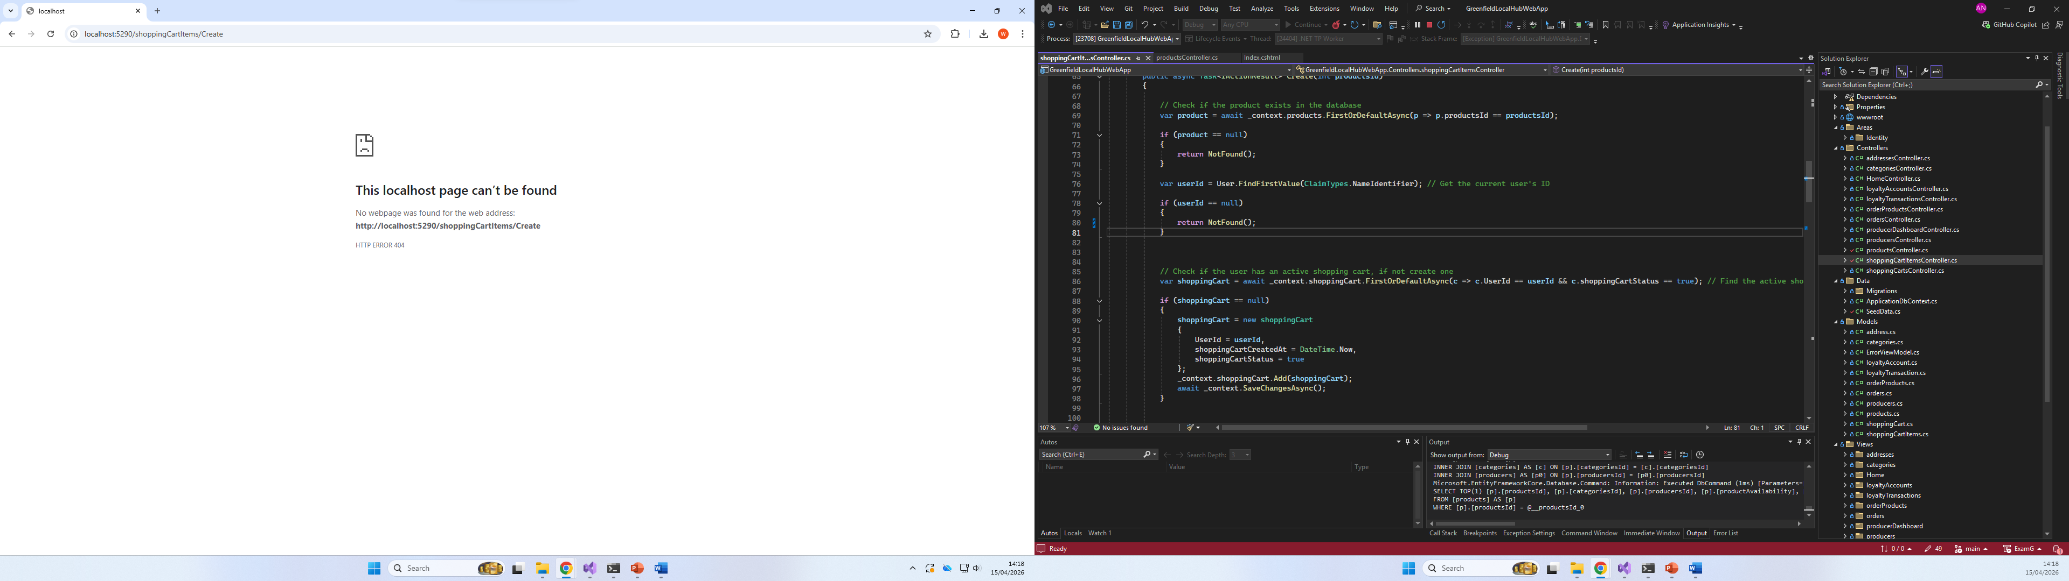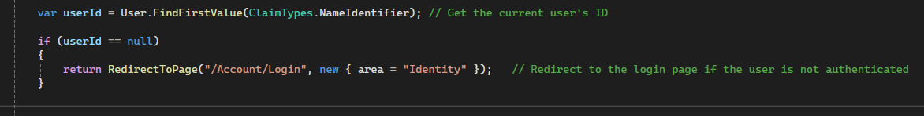
- Instead of using return NotFound in the shoppingCartsItemsController, I used the RedirectToPage method for a better user experience.

- My filters were not filtering when pressed, so I used a safer method to handle the filtering, which is making separate controller action for each filtering method in the products controller. [Get a Screenshot]

- Now Filtering for the user works amazingly, but a problem occurred for a logged in producer. The products page displays only the logged in producers products which is fine, until they decide to filter the products. That’s when other producers products shows after filtering, so I added role-based filtering as well to fix the issue. [Get a Screenshot]

- Another problem, is that any user (even not logged in users) could edit or delete a producer from the page which is absolutely not allowed. 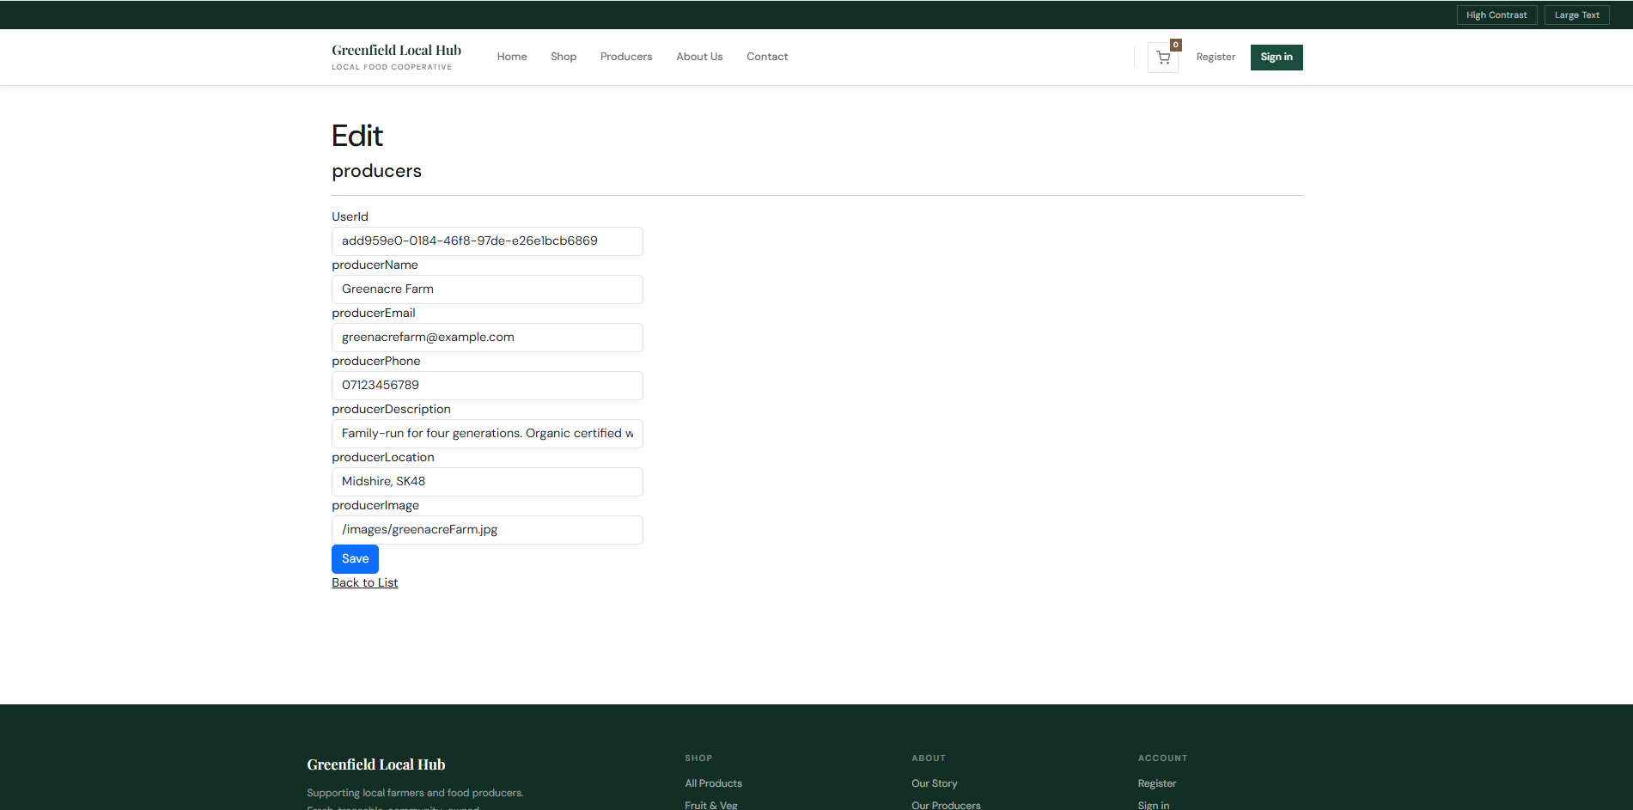
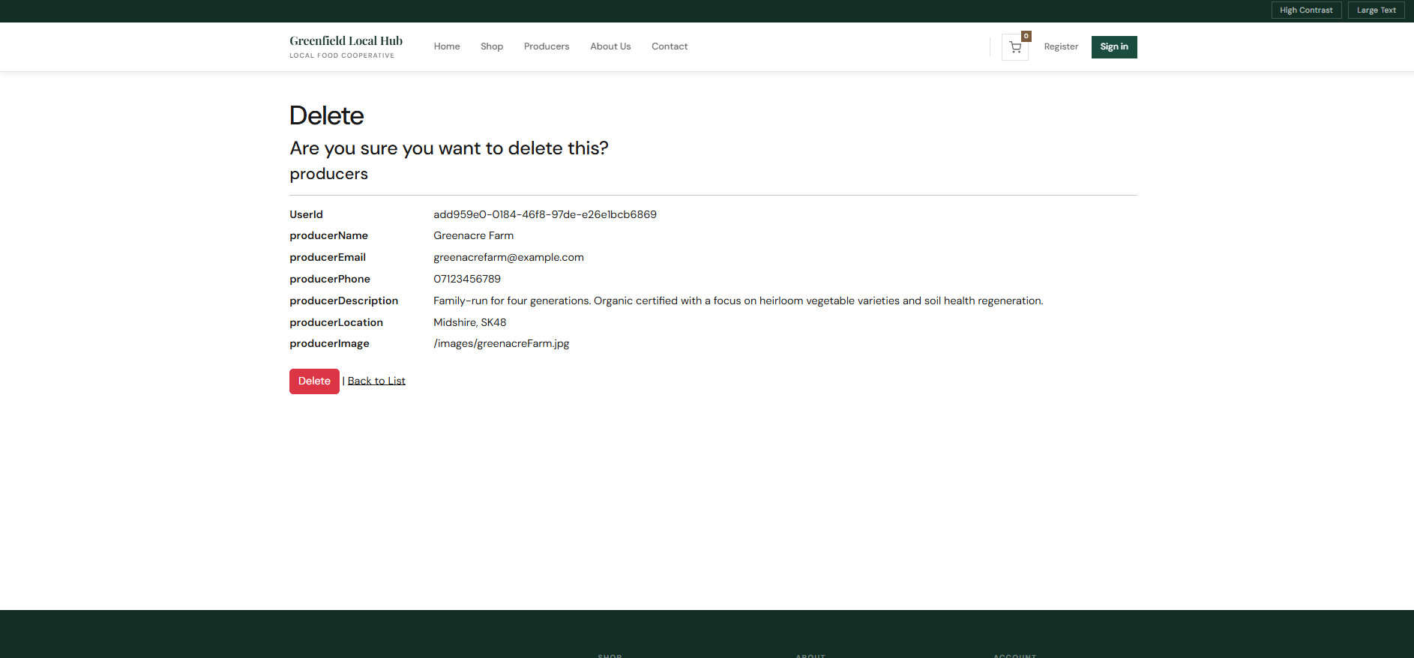

- When filtering by category and the user wants to sort the filtered products, the category filtering is removed and vice versa.

- When a user uses filters in the shop, and adding a product to the cart while the page is filtered, the page refreshes and the filtering is removed so the user is back to the initial page. The user should still see the filtered products they had even if they add to cart. So I fixed the filtering method in the controller.

// Redirect back to the return URL if provided, this is if the user added a product while filtering the page so they are redirected to the filtered view.

- Search function isn’t great, the user must be accurate in spelling to receive the results they want, it is not very user friendly. Also when searching the filters are automatically removed if applied, which isn’t great either.

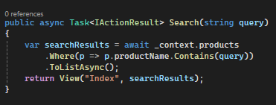

- Having more then 12 products in one page is a lot and could cause slower loading speed for the page, therefore pagination must be implemented.

